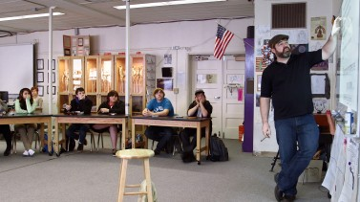

Location Here
Date and time here

Paper Tigers is an intimate look into the lives of selected students at Lincoln High School, an alternative school that specializes in educating traumatized youth. Set amidst the rural community of Walla Walla, WA, the film intimately examines the inspiring promise of Trauma Informed Communities - a movement that is showing great promise in healing youth struggling with the dark legacy of Adverse Childhood Experiences (ACES).

Location

Sponsors |  | Other sponsors go here

Program

Times and agenda go here

Clock Hours 2.5

